**WriteUp**

Deployed ELK Stack on a Docker container to implement continuous monitoring.

* Docker: created a container for installing ELK Stack

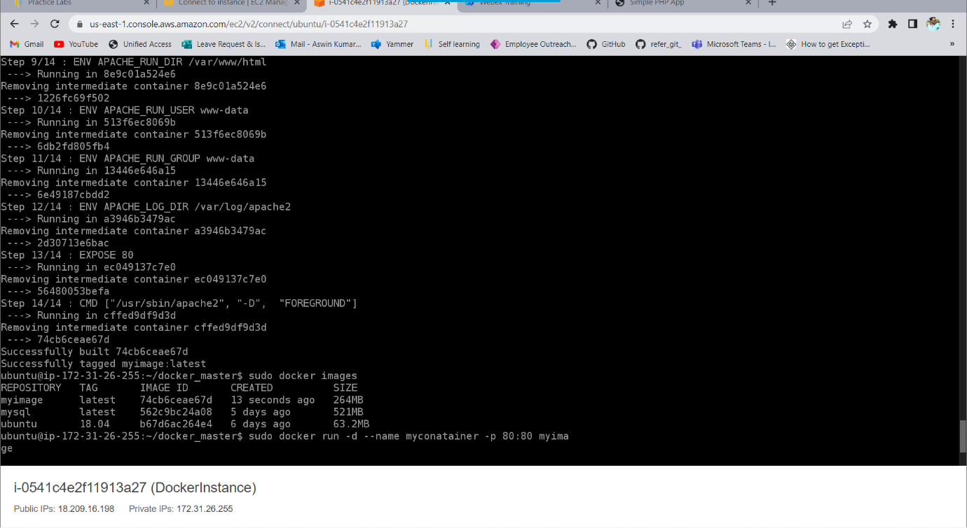

* ELK Stack: To implement continuous monitoring

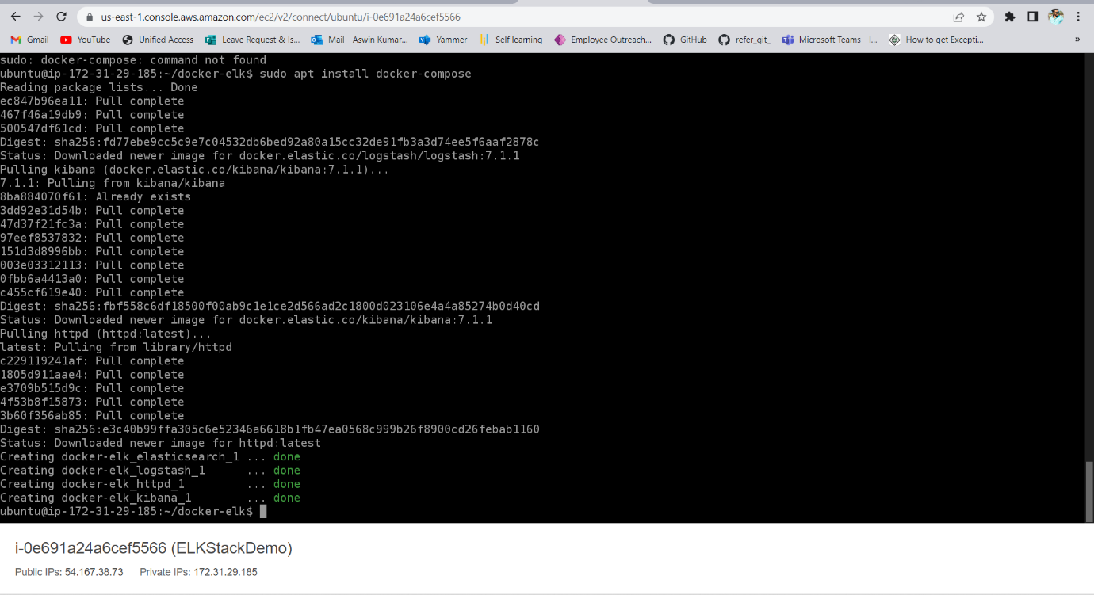

* GitHub: To store the Angular application

Technologies Used:

* EC2 Instannce
* Docker
* ELK Stack
* GitHub